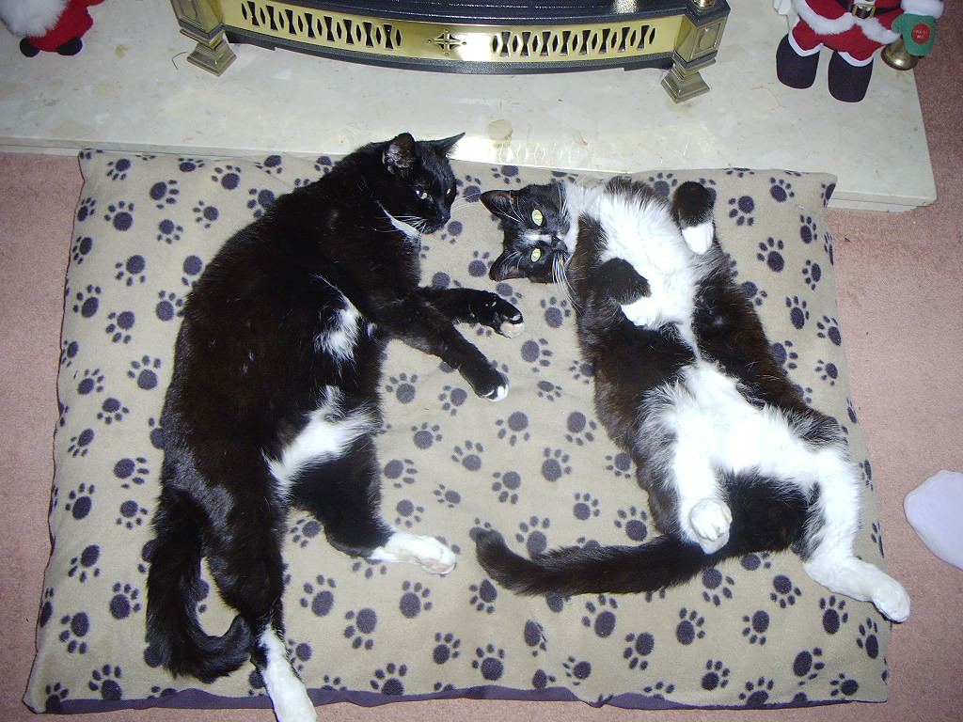

Furbawlz!
Fur Play
- Hooks in You
- Ice Cream Man
- My Guitar’s Gonna Kill Ya Mama
- Blowin Free

Fur Bookings:-

Tony 07900903309
John 07795234107
www.furbawlz.co.uk (from 1-April-04)

